Dear parents and carers,

It has been brought to my attention that there are cases of threadworm in the school. It is not serious but it is not pleasant to have and is **highly contagious if not treated.**

If you discover that your child has threadworm, you will not need to go to the GP but please get the relevant advice and treatment by visiting the local chemist. Threadworm does not require children to take time off school but **treatment must be started immediately**. It is also advisable that everyone within the household gets treatment for this, even if they do not have any symptoms. This treatment is then repeated after 2 weeks. The medicine kills the threadworms, but does not kill the eggs. Eggs live for up to 2 weeks outside the body.

More information can be found at <https://www.nhs.uk/conditions/threadworms/>

**Preventing threadworms and treatment:**

* wash hands and scrub under fingernails – particularly before eating, after using the toilet or changing nappies
* encourage children to wash hands regularly
* shower every morning
* rinse toothbrushes before using them
* keep fingernails short
* wash sleepwear, sheets, towels and soft toys (at a hot temperature) every day for several days after treatment
* disinfect kitchen and bathroom surfaces, using hot water
* vacuum and dust with a damp cloth
* make sure everyone in the household wears underwear at night and changes it in the morning

Please encourage regular hand washing and we will be doing extra at school too.

Threadworm is very common in school age children therefore I ask you to support the school community by carrying out these checks and obtaining treatment if necessary. Please also inform the school if your child has threadworms.

Regards

Miss De Filippis

**Threadworms**

More information can be found on the NHS website More information can be found at <https://www.nhs.uk/conditions/threadworms/>

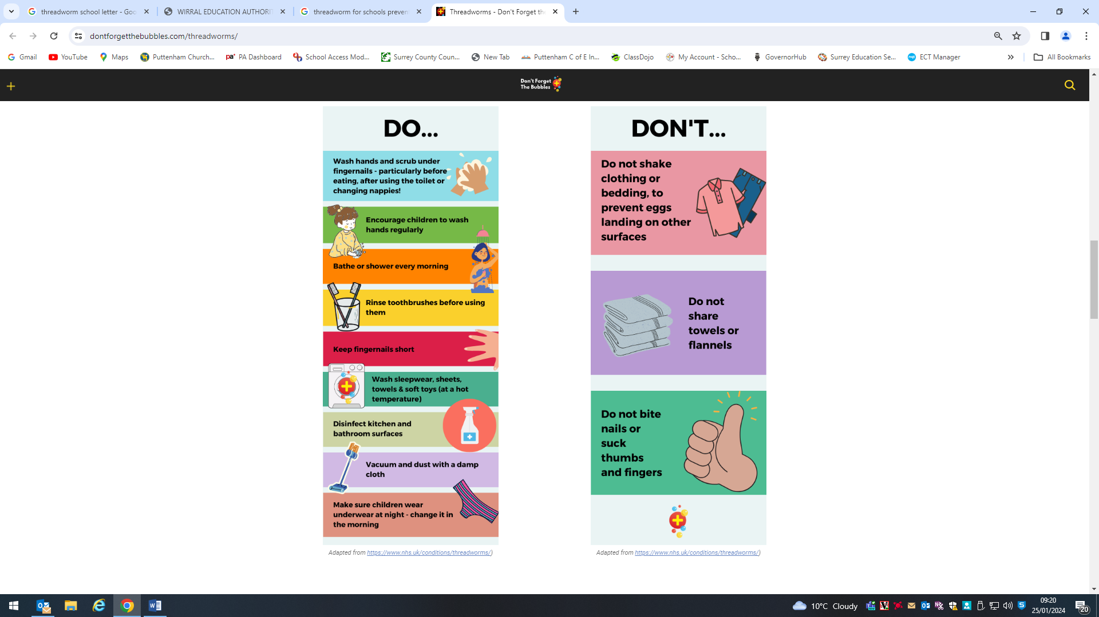

You tube Dr Sarah explains Threadworms <https://www.youtube.com/watch?v=Z31GQpj-H2M>